PORT ISAAC AND TRURO TOP LIST OF ‘TV STAYCATIONS’ FOR BRITS
- Port Isaac and Truro named within the top three places Brits want to visit this summer, thanks to popularity of TV shows Poldark and Doc Martin
- TV tourism is booming with more than half of Brits planning staycations inspired by TV shows
- Virgin Media O2 has launched TV Mapper, a first-of-its-kind tool allowing TV enthusiasts to find where their favourite shows are filmed
- Fans of Poldark and Doc Martin can explore iconic locations via curated routes available to download from the site

Port Isaac and Truro are set to see an influx of staycationers this summer thanks to the popularity of TV shows Poldark and Doc Martin.
New research, commissioned by Virgin Media O2, found that Port Isaac topped the list of places Brits want to visit this summer after seeing it on TV, with Truro following closely in third position. The list was compiled to launch its new TV Mapper tool – an interactive map which allows TV fans to discover where in the UK their favourite shows are filmed.
With more than half (56%) of Brits visiting UK destinations after seeing them on screen, and nearly a quarter (21%) enjoying a TV-inspired staycation in the past year, it seems ‘TV tourism’ is set to boom this summer.

Virgin Media O2’s TV Mapper allows users to search by show, genre or region; plan the ultimate fan route and follow in the footsteps of their favourite characters, virtually or in person.

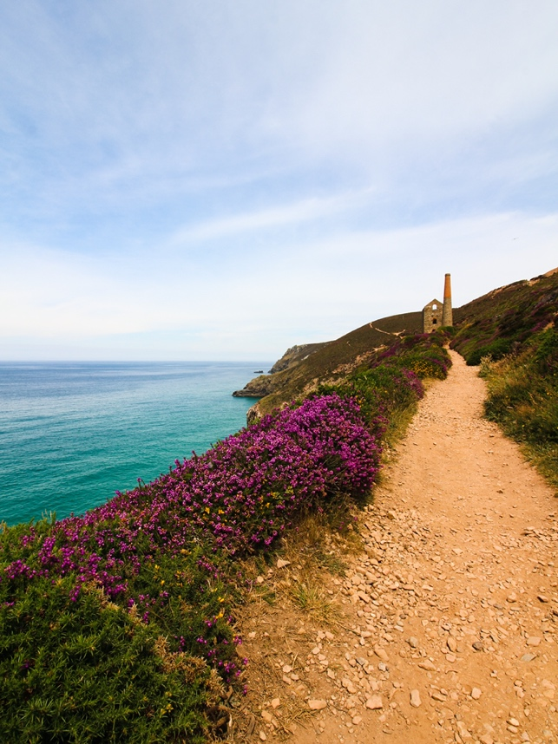
Figure 1 - St Agnes Head and Chapel Porth, Cornwall

Using the tool, Poldark enthusiasts can discover Truro’s beauty spots such as St Agnes Head and Chapel Porth, a short drive from the Cornish town, which is best known for the scenes when Poldark rides his horses; or visit the home of the Poldark family, Bodmin Moor, and be transported to the 17th century with its rocky tors, granite exterior and moorland views.

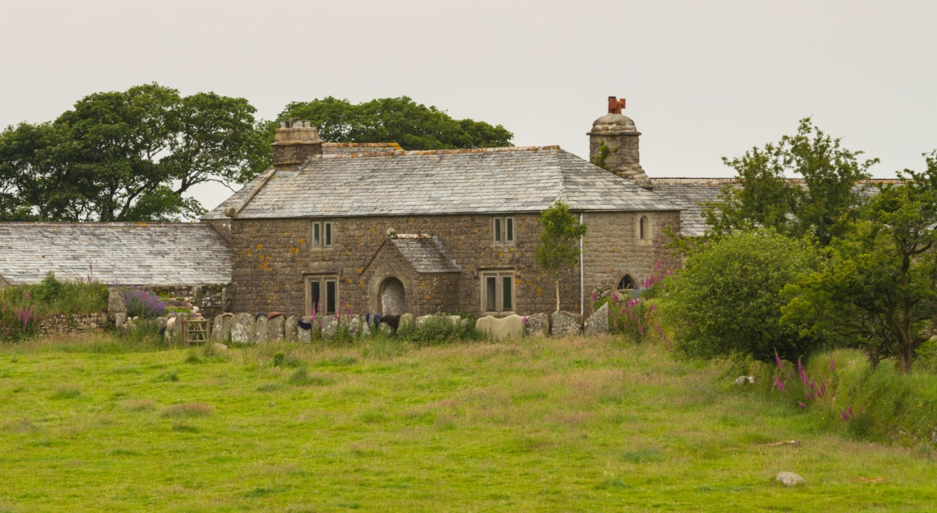
Figure 2 - Nampara Cottage, Cornwall
Doc Martin fanatics can also discover Port Isaac’s famous landmarks from Fern Cottage, the Grade II listed building which doubles as Doc Martin’s surgery, to The Old School House, where headstrong headmistress, Louisa, works at the school.

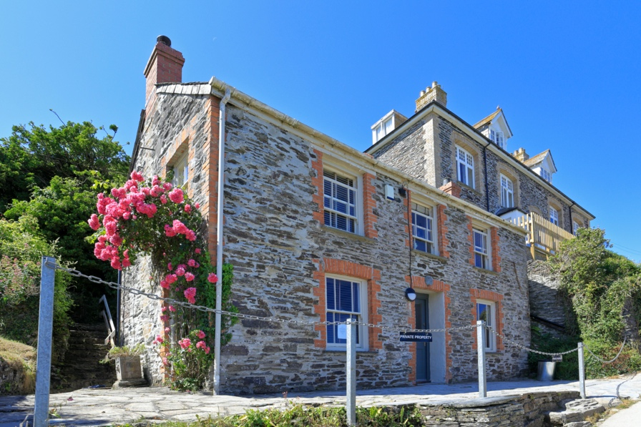
Figure 3 - The Old School, Cornwall
Viewers can also grab a bite to eat at The Golden Lion in Port Isaac, which often makes an appearance on the show as Doc Martin’s local, making for a perfect end to a TV-inspired tour of Cornwall.

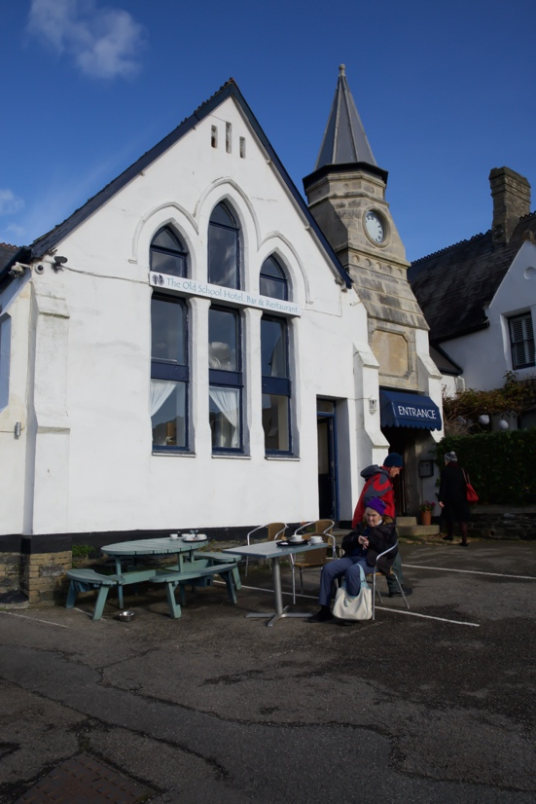
Figure 4 - The Golden Lion, Cornwall

TV fans can explore the UK filming locations of their favourite shows by visiting: https://www.virginmedia.com/blog/tv/filming-locations
David Bouchier, Chief Digital Entertainment Officer at Virgin Media O2, said:
“TV became a lifeline in lockdown when we were only able to escape through our screens.

“Now things have opened up, we’re seeing a rise in TV tourism, as holidaymakers have been inspired by scenes of programmes set in the UK.

“With TV Mapper, we’re taking this to the next level by mapping iconic UK filming locations in one place, making it easy for TV fans to get closer to their favourite shows – whether that’s walking the grounds of Downton Abbey or exploring the Cornish coastline featured in Doc Martin.”

In time for the summer holidays, Virgin Media O2 has boosted its mobile network in thousands of UK TV tourism hotspots, making it even easier to plan a staycation route or share selfies on-the-go.
Malcolm Bell, Chief Executive at VisitCornwall, added: “Cornwall is one of, if not the top, holiday destinations and TV imagery of our beautiful coast and countryside is our most powerful promotion channel. It is exciting to see that Truro, our great little city, has been chosen as the top TV staycation location in Virgin Media O2’s survey. Although we have two stunning coasts, the inland towns are often the best unknown, yet equally amazing, places to visit.”
Google search data uncovered by Virgin Media O2 shows a 174% uplift in searches for ‘staycation’ in the last year alone, as Brits look for local holiday ideas while navigating travel restrictions.

THE TOP 10 UK DESTINATIONS BRITS HAVE VISITED – OR WOULD LIKE TO VISIT – AS A RESULT OF TV:
- Port Isaac – “Doc Martin”
- Highclere Castle – “Downton Abbey”
- Truro – “Poldark”
- Holmfirth – “Last of the Summer Wine”
- Bath – “Bridgerton”
- Scotland – “Outlander”
- Barry Island – “Gavin & Stacey”
- West Bay – “Broadchurch”
- London – “The Bodyguard”
- Cardiff – “Doctor Who”

Notes to Editors
The survey of 2,000 UK adults was carried out by OnePoll between 18th to 23rd June 2021.
The analysis of the most searched for TV show and the increase in searches of ‘staycation’ is based on Google search data captured between May 2020 and May 2021.
About Virgin Media O2
Virgin Media O2 launched on 1 June 2021, combining the UK’s largest and most reliable mobile network with a broadband network offering the fastest widely-available broadband speeds. It is a customer-first organisation that brings a range of connectivity services together in one place with a clear mission: to upgrade the nation. Virgin Media O2 is the corporate brand of the 50:50 joint venture between Liberty Global and Telefónica SA, and one of the UK’s largest businesses.
The company has 47 million UK connections across broadband, mobile, TV and home phone. Its own fixed network currently passes 15.4 million premises alongside a mobile network that covers 99% of the nation’s population with 4G, and over 180 towns and cities with 5G services. Virgin Media O2 is committed to delivering gigabit broadband speeds across its entire network footprint by the end of 2021.
Virgin Media O2 is a major investor in the UK. It employs around 18,000 people, has more than 430 retail stores and has committed to invest at least £10 billion over the next five years.
As integration work progresses at pace, both Virgin Media and O2 continue to offer their respective products to customers, with new, joint services launching soon.
Today, the business delivers award-winning broadband and WiFi connectivity to homes as well as providing a connected entertainment service. This brings together live TV, thousands of hours of on-demand programming and a wide-selection of apps to customers through a set-top box and on-the-go through tablets and smartphones.
It also provides 2G, 3G, 4G and 5G mobile services, and is the network of choice for mobile virtual network operators giffgaff, Sky Mobile and Lycamobile, as well as managing a 50:50 joint venture with Tesco for Tesco Mobile.
Virgin Media O2 Business plays a leading role in supporting the public sector and businesses of all sizes. This includes a variety of managed connectivity services and flexible working capabilities, security, data insight, 5G private networks and cloud solutions, as well as wholesale services to other operators and partners
Awards for Virgin Media and O2’s telecommunications services include recognition by GWS for having the most reliable UK mobile network for three years in a row (2021, 2020, and 2019) and winning the publicly voted Uswitch awards in 2021 for the fourth consecutive year for Best Network Coverage (mobile) and Fastest Broadband Provider.
Virgin Media O2 is committed to using the power of connectivity to supercharge communities across the UK, taking action to close the digital divide and helping to build an inclusive, resilient, and low carbon economy. The company has an ambition to achieve net zero carbon operations (scopes 1 & 2) by the end of 2025.

