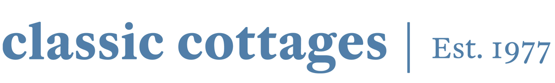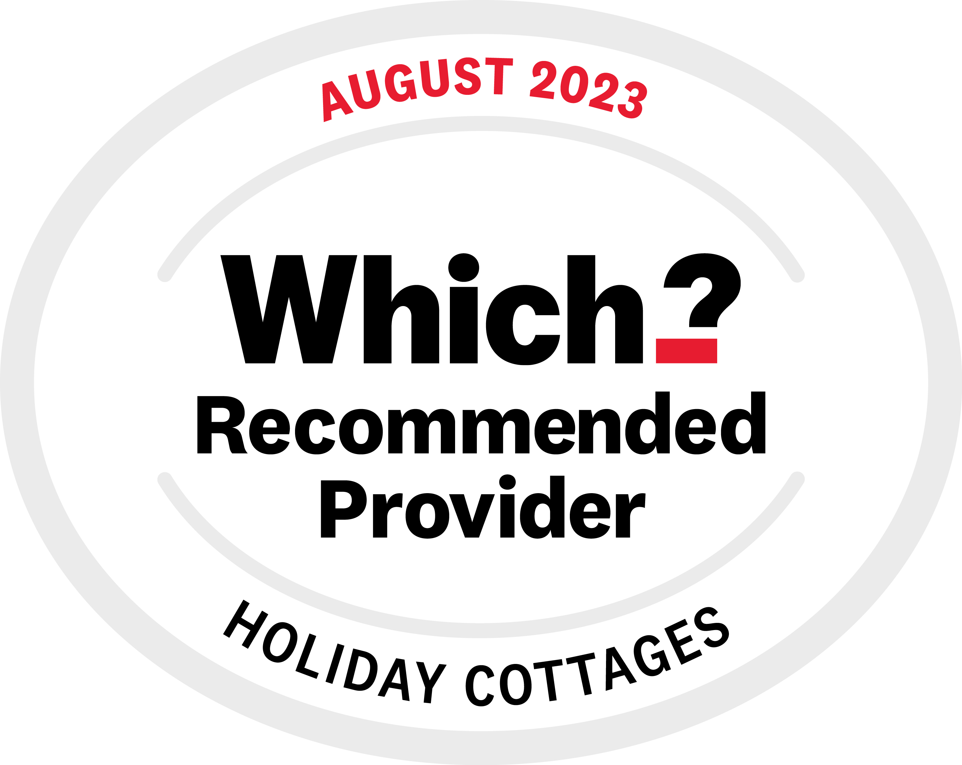

Classic Cottages Maintains its Which? Recommended Provider Status
For Third Consecutive Year Following Latest Survey

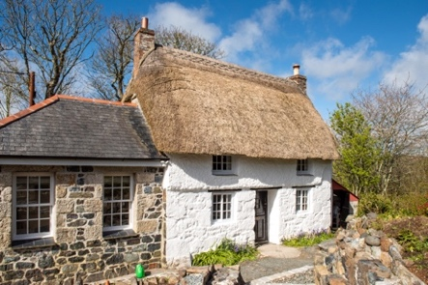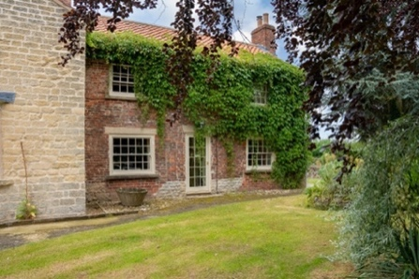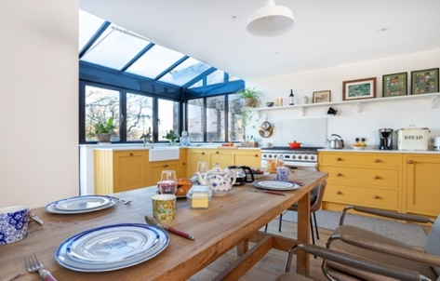

Images here

1 November 2023…// Classic Cottages, the largest independent holiday letting agency in the UK has recently been labelled as a Which? UK Holiday Cottage Recommended Provider for the third consecutive year. Out of all the cottages recommended by Which? Classic Cottages was ranked second out of all holiday cottage companies in the UK.

Classic Cottages was upon some of the highest-scoring holiday cottages companies in the service and has been awarded for its five-star customer service, quality of cottages and value for money. The letting agency has also been commended for being run by the same family which started the business in 1977. Due to its success, Classic Cottages now has over 1,400 properties all over the UK and is set to launch in Scotland very soon.

Which? generated a survey with over 3,000 members providing feedback on UK holiday cottage providers resulting in Classic Cottages being awarded second place with Which? commenting, “Forget Hoseasons and Sykes: here you’ll find better cottages and customer service, for a good price.”

Dan Harrison, Commercial Director at Classic Cottages, commented: “I am delighted that we have been named as a Which? Recommended Provider for the third year running. It is all down to the hard work of our team who go out of their way to provide our guests and holiday cottage owners with the best service and experience possible.”

Companies are awarded Which? Recommended Provider status after thorough research and investigation by the Which team, based on Which’s independent assessment benchmarks and impartial customer scores and star ratings collected through regular surveys. Which? choose companies to assess via an independent selection process and use experts to analyse their terms and conditions. Holiday cottage companies must meet certain standards. Including quality of cottages, cleanliness, description vs reality, customer service and value for money.

Established in 1977, Classic Cottages is the largest independent holiday letting agency in the UK, offering an incredible selection of holiday homes, all exclusively available through Classic Cottages. With over 45 years of experience, the company has an impressive, carefully curated portfolio of over 1,400 properties to rent across the UK, all of the highest standard. From secluded countryside cottages, cliff-top cabins and houseboats to beachside boltholes and shepherd’s huts, there is something for every type of traveller.

Classic Cottages is proud to receive the accreditation and is grateful to all of the property owners and members of the team who have helped in achieving this status. If you would like to read the full Classic Cottages review, take a look at the article here.

- ENDS –

For further information please reach out to the team at Grifco PR on classiccottages@grifcopr.com

About Classic Cottages

Established in 1977, Classic Cottages is the UK’s largest independent holiday letting specialists, marketing a portfolio of high-quality properties across the UK, all of which are exclusive to Classic Cottages and will not be found on other sites. As a Tourism Quality Accredited Company, Classic Cottages has been given a Gold Award for the high level of service it provides as a business, as well as a Feefo Platinum Trusted Service Award 2023 for its excellence in customer service. Which? Awarded Classic Cottages the status of Recommended Provider for UK Holiday Cottages in 2021, 2022, 2023 and 2024 commended for excellent customer service, accuracy of cottage descriptions, website quality and reasonable prices. www.classic.co.uk.

